**IUlogo**

FACULTY OF ENGINEERING, SCIENCE & TECHNOLOGY

**Week 5 Class Task**

Subject: Operating Systems (Lab)

**Question no 01:**

Write shell script to print table of any given number

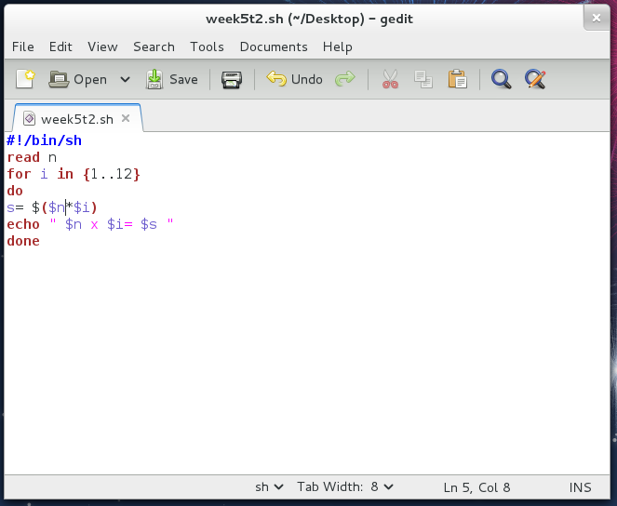

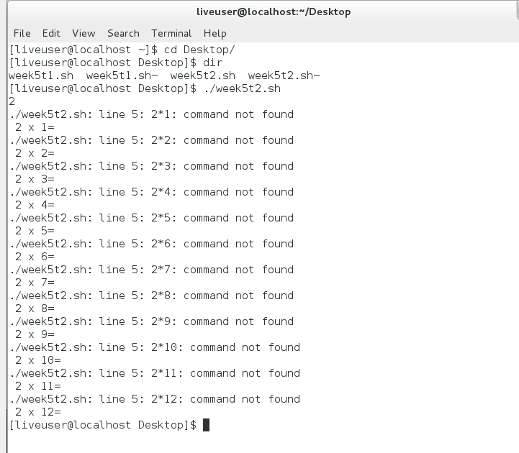

**Question no 02:**

Write shell script to calculate GPA of 2 courses having 3 crd hrs and a lab having 1 crd hr

